**Orion Trail 2: Escape The Station Game Manual**

**By: Liam Vukasinovic and Ian Grenville**

**What is Orion Trail 2?**

Orion Trail 2 is a top down shooter that takes place in a space station. At the start of the game mission control tells you that you are on a spaceship that is going to self destruct in five minutes. You must get through the alien infested station to an escape pod in five minutes or else you lose. Throughout the game you can encounter many different items that can help you through your journey such as med kits and better guns.

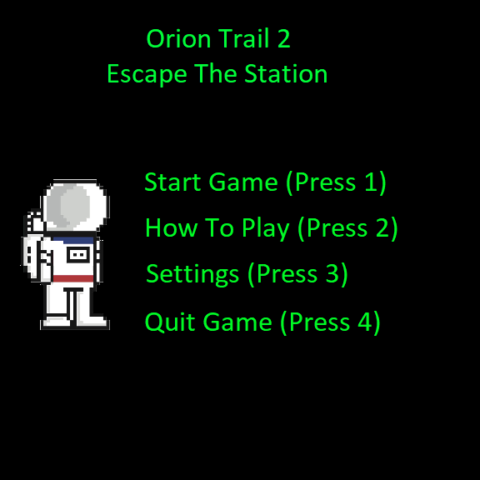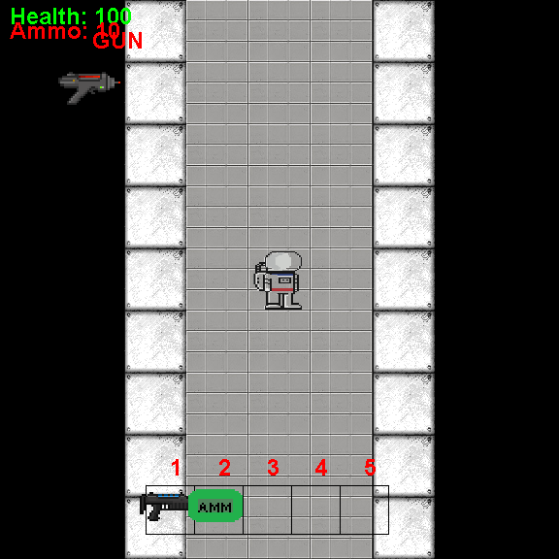

**Controls**

When you first launch the game you are faced with a loading screen. To navigate the screen you must press the corresponding button that is beside what you want to do (as seen above). You can either start the game, learn how to play, goto the settings, or quit the game.

In the game you control your character with the keys WASD, you use the mouse to point where you want to shoot and click to shoot, you also use the keys 1-5 to use the items that you pick up. Other than that the game is very basic and easy to play.

**Your Stats**

**Health**

In the game you start off with 100 health, the only was that you can lose health is through aliens attacking you. If you hit 0 health then you die and lose the game. The one way you can get your health back is by picking on med kits around the map

**Ammo**

Your starting gun, and each gun you pick up throughout the game starts with 10 bullets. Same goes as said above, if you hit 0 ammo your gun will not work anymore and to get more ammo you need to find ammo packs around the map.

**Aliens**

In the game the one enemy that you will encounter is are aliens. These aliens will randomly move around the mad but if they get too close to you then they will deal 10 damage per hit. Each alien has 100 health and the way you can take these enemies out is by shooting them with your weapon.

**Items**

Throughout the map you will find all sorts of items, these items are:

**Medkits**

If you use a medkit it will heal 20 health. You will not be able to use this item while at 100 health.



**Weapons**

There are three guns that are in the game. These are the starting gun, these one is the basic one. The other two are upgrades that you have to find around the map.

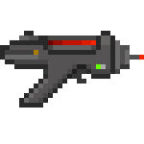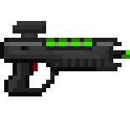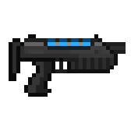

**Ammo Packs**

This item will give you five more bullets upon use. You can use this item even when at the starting amount of 10 bullets.



**Strategies**

The two strategies that can help you in winning the game are:

**Stacking Up Items**

In the game you have five inventory places, use this to your advantage. You can stack medkits and ammo packs in your inventory that you can use later on for if you run to low on health or run out of ammo. Don’t underestimate the value of the items!

**Speed Run**

Spending too much time at the start of the game trying to take out as many aliens as you can has its advantages, but it sometimes is not ideal. This can waste lots of time on your clock causing you to have to rush the rest of the game, or the aliens could do too much damage to you and you will die before you can end the game.

**Winning**

To win the game, you must make it through the space station to the escape pod alive and within the five minutes. You will see this screen upon winning.

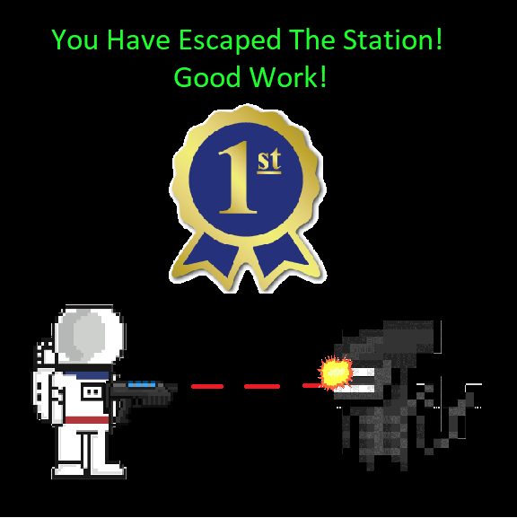

**Losing**

There are two ways that you can lose the game. These are if you hit 0 health then you will die. The other way is by not making it to the escape pod within the five minute time limit. You will see this screen upon losing.

